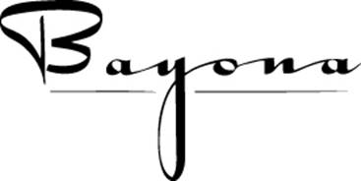
430 Dauphine Street
New Orleans, LA 70112
504-256-7333
www.bayona.com

3 Course Private Lunch Contract 2023

Contact: ____________________________ On-Site Contact: _________________________________

E-mail: _________________________________ Cell Phone: _________________________________

Credit Card Type: ___________________ Exp. Date: _______________ CVV#: ____________

Credit Card Number: __________________________________

Name of Function: _________________________________________No. of Guests: _____________________________

Date of Function: ________________ Day of Function: ________________ Time of Function:___________

Please confirm party size and date TWO DAYS PRIOR at 504-525-4455

MENU AS PRINTED THAT DAY

Hors d’oeuvres: Chef’s selection du jour ($3.00 per person) YES NO
If yes, (2 per person recommended), please indicate number: _______________
(This must be determined the same day you complete the contract)
First Course: Choice of:
Bayona Salad
Caesar Style Salad
Garlic Soup
Soup du Jour

Main Courses: Choice of:
Fish du Jour
Pan-Roasted Chicken Breast w/Charcutiere Sauce, Mushrooms, Seasonal Vegetables
Grilled Lamb Loin with Herbed Goat Cheese and Zinfandel Sauce
Duck Sandwich with Cashew Butter, Pepper Jelly and Apple Celery Salad
Seasonal Vegetarian Option is Available

Desserts: Chef Seasonal Selections

Beverages: Full bar, with wines and non-alcoholic beverages are charged on a consumption basis. Pre-wine selection is recommended. Call 504-525-4455

Set Up: The “Wine Room” can seat a maximum of 30 at 3 round tables of 10 each.
It is not wheelchair accessible and does not have audio/visual capabilities.
Part

Payment: One Credit Card per table. No individual checks.

Total Cost: $55 per person for food, plus beverages, 10.45% tax and 20% gratuity.

Cancelation Policy:
Please confirm number of guests 24 hours prior. If actual party size is smaller than confirmed, $25 per person no show, will be charged.

Regina Keever Bayona,

Regina Keever_________ Date:
Reginakeeverbayona@msn.com

__________________________________ Date:
Private Party Representative

