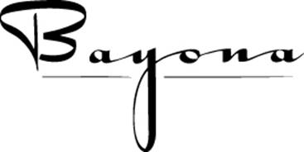
430 Dauphine Street
New Orleans, LA 70112
504-256-7333
www.bayona.com

"BAYONA BUYOUT"
Bayona can be your French Quarter celebration place for that very special day or evening. The entire 250-year-old charming Creole Cottage and Romantic Tropical Courtyard is a stunning location to host your guests of up to 100. To start, there will be a champagne reception with hors d’ oeuvres. Chef will prepare a 4-course custom menu of your choice. Being a part of designing the menu with Chef is a special touch our guests so enjoy. Choose from a list of premium liquor and premium wines to pair with each course, with the help of our Wine Steward. Let the chef amaze you with a custom dessert. May we suggest an after-dinner port or liqueur to finish. Remember, the restaurant, the courtyard, design of the menu and beverages are all yours to choose and enjoy, giving your invited guests a most memorable New Orleans experience. Live music is welcomed.
I would love to help you with any questions you have. 504 256 7333

Sunday through Thursday = $20,000 plus 10.45% tax and 20% gratuity
Friday and Saturday= $22,000 plus 10.45% tax and 20% gratuity
*Lunch Buyouts and smaller options are also available, 7 days a week.
*Please call me for more information and pricing options.

Regina Keever,
Regina Keever
Owner and Event Coordinator

