To begin… 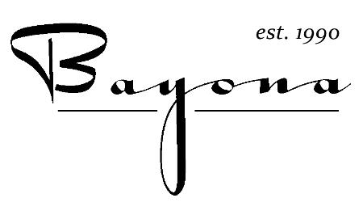
Cornmeal Pancakes 10
Lemon Mascarpone, Blueberry-Thyme Compote
Cauliflower Fritti 10
Lemon Anchovy Aioli
Kimchi Fried Rice 12
Fried Egg, Gochujang Sauce, Herbs
Louisiana Crab en Croute 16
Mushroom, Leek, Crème Fraîche
Traditional Snapper Ceviche 14
Jugo de Tigre, Crispy Tortilla

Next…
Cream of Garlic Soup 7
Caesar-Style Salad 9
Arugula, Romaine, Preserved Lemon, Garlic Croutons, Fried Caper
Crispy Quail Salad 15
Mixed Lettuces, Pickled Red Onion, Candied Pecans, Bourbon Molasses Vinaigrette

Then…
Smoked Duck “PB & J” 18
Cashew Butter, Pepper Jelly, Apple-Celery Salad, Wild Flour Multigrain
New Orleans Style BBQ Shrimp 19
Stone-ground Grits, Smothered Greens
Carbonara 16
Bayona Bacon, Cremini Mushroom, Louisiana Sweet Peas
Steak and Eggs 28
Poached Egg, Duck Fat Potatoes, Salsa Verde

Finally…
Banana Fritters 10
Chocolate Sauce
Polenta Pound Cake 9
Apricot Preserves, Salted Cultured Butter

